Volume 2, Issue 10, October 2012 ISSN: 2277 128X
International Journal of Advanced Research in
Computer Science and Software Engineering

Research Paper

Study of Cloud Setup for College Campus

Vinay Khedekar Girish Mane Siddhi Khanvilkar Shreedhar Karade
Information Technology Mumbai University India

Prof. Atul Yadav
Information Technology RMCET
India

Abstract— Cloud Storage is an attractive concept in IT field since it allows the resources to be provisioned according to the user needs. It provides services on virtual machines whereby the user can share resources, software and other devices on demand. Cloud services are supported both by Proprietary and Open Source Systems. The project idea is about to provide cloud storage to store and upload the data for the teachers as study material, Assignments and other stuff. These drives also allow to the principal and Examination cell authorities to upload the current notices for
student. The designed cloud storage (Drive) is used within Intranet by using LAN connection and also by using Wi -Fi. The Drive facilitates staff with a separate and limited space to store and upload data with its own access privileges.

Keywords— cloud computing; Cloud storage; Openstack; Open source; Intranet.

INTRODUCTION
Cloud computing is a computing environment, where resources such as computing power, storage, network and software are abstracted and provided as services on the internet in a remotely accessible fashion [5]. Billing models forthese services are generally similar to the ones adopted for public utilities. On -demand availability, ease of provisioning, dynamic and virtually infinite scalability is some of the key attributes of cloud computing [1]. The main aim of cloud computing is providing services. It provides various types of services, some of the important services are SaaS, PaaS and IaaS.
A. Software as a service (SaaS): It is a model of Software deployment whereby according to the demand of the customer a provider provides licensed application for the specified time.
B. Platform as a service (PaaS): Generates all facilities required to support the complete cycle of construction and delivery of web -based applications wholly available in Internet with built in services so there is no need of downloading software or special installations by developers.
C. Infrastructure as a Service (IaaS): It provides resources, such as servers, connections, storage and other necessary tools to construct an application design according to the need of organizations, making it quick, easy and economically viable. Cloud computing is mainly classified into three types based on the deployment model: Public cloud, Private cloud and Hybrid cloud. If the services are provided over the internet then it is public cloud or external cloud and if it is provided within an organization through intranet then it is named as private cloud or internal cloud and Hybrid cloud is an internal/external cloud which allows a public cloud to interact with the clients but keep their data
secured within a private cloud [2]. In this work we propose and discuss the design and Implementation of cloud service in college .We have seen implementation of cloud on larger scales in companies like Amazon etc, but not for college level. We are going to design a cloud setup for institution like college where request patterns and infrastructure are quite different from commercial settings.

The college can benefit significantly from private cloud infrastructure to service its various branches, research, and teaching requirements. Atul et al., International Journal of Advanced Research in Computer Science and Software Engineering College consists of various department like information technology, computer, mechanical, automobile, etc. Each department has different computer labs .Each branch requires different software, platforms which are purchased by the college which needs to be installed on every computer of different labs according to the requirement. Thus by setting up the cloud there will be no need of doing so .All the software and form need to be installed only once which will be stored on cloud server. The designed cloud storage (Drive) is used within Intranet by using LAN connection and also by using Wi-Fi. Principal of the college will be admin. So that all activities performed by staff members and students will be known to him. Each student and staff member will be assigned a unique-id for login purpose which will help in maintaining security.

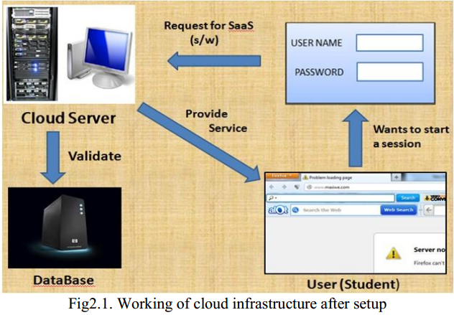

For example the above figure shows that whenever a student request for a particular software or platform he has to login using his/her id Allocated to him/her. If he/her is a valid user then the request is forwarded to the Cloud server .The cloud server with the help of database server validates the user and provides services.

The users of the drive are as follows:

a) Staff- Have rights to upload data.
- Have rights to upload Softwares.
- Have rights to download data.
- Have rights to add platform, software etc.
- User name as Employee ID.
- Password will be user defined.

b) Examination-cell authorities-
    - Can upload notices about Examination.
    - Can upload various Examination Results.

c) Principal-
- Can upload notices regarding student and teachers.
- Can give suggestion to teachers and students.
d) Student-

- User name as Student ID and password-user defined.
- Have only access to read and download data.
- They can give feedback to teachers.

B. Physical setup of cloud

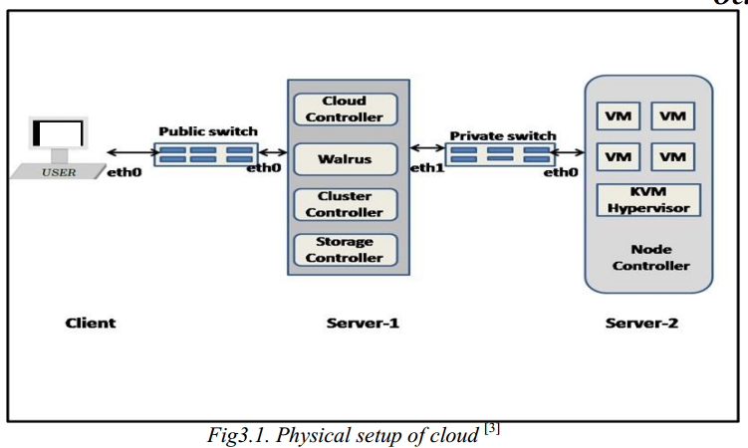

For physical setup, the requirements are as follows:
1) Two servers: Server 1 i.e. Cloud server.
Server 2 i.e. Node Controller
2) Multiple clients: Users
The user will be communicates with server1 which is a cloud server with the help of public switch. The server 1 and server 2 will communicate with each other using private switch.

III. REQUIREMENTS

A. Software requirements:
- Windows Server, 32 / 64-bit Server CD

B. Hardware requirement:
- Core i3 machine
- 8 GB DDR3 RAM
- 1 TB HDD
- NETWORKING

VI. FUTURE SCOPE

Additional software and platform can be included in cloud for the benefit of students. Softwares as well as platform must be updated with new versions. More features must be added with advance security measures.
This cloud infrastructure helps organizations for upgrading their facilities and adding new features to all users of it. It will reduce the hardware cost as well as software installation efforts.

VII. CONCLUSION

Cloud computing is an everlasting computing environment where data are delivered on-demand to authenticated devices in a secured manner and users utilize a shared and elastic Infrastructure. This paper briefly explains the set up of a private cloud in a cluster based environment using open source technologies like Eucalyptus, Openstack, MAAS and Juju. Services were included successfully and made available to the user. The current implementation of this paper provides Platform as a service (IaaS) and Software as a Service (SaaS).

